EBD #6.0
2021
TO: ALA Executive Board

RE: Development Office Fundraising Report to the Executive Board

ACTION REQUESTED/INFORMATION/REPORT:
Development Office Fundraising Report to the Executive Board

CONTACT PERSON:
Tracie D. Hall, Executive Director, ALA
Anne Manly, Assistant Director of Corporate and Foundation Relations, amanly@ala.org

DATE: January 15, 2021

DEVELOPMENT OFFICE FUNDRAISING REPORT TO THE EXECUTIVE BOARD

BACKGROUND: The purpose of the ALA Development Office report to ALA Executive Board Members is to provide an overview of the progress made by the American Library Association (ALA) and its units in their strategic fundraising efforts. The Development Office and ALA units expend significant effort in identifying, cultivating, and soliciting major and planned gifts; participating in donor activities for purposes of relationship building, cultivation, and stewardship; drafting proposals and meeting with individuals, foundation, and corporate donors for cultivation and solicitation purposes.

Fundraising Accomplishments
The following are highlights of ALA’s Fundraising Activities, and Organizational Excellence since June 2020:

Association of College and Research Libraries

ACRL received $10,815 from 116 donations. Of that amount, 51.3% was donated to the ACRL Advancement Fund, 36.6% to the ACRL Conference Scholarship Fund, and 11.9% to the Rare Books and Manuscripts Section Scholarship Fund. For the first time, we offered a free bonus gift to all who donated $25 or more. Donors could choose between free access to an ACRL e-learning session or one free e-book.

Association of Library Services to Children

This giving season, in alignment with ALA’s theme, ALSC’s solicitation messaging highlighted ALSC’s work in the areas of media mentorship and digital equity. This messaging featured ALSC’s successes through #LookToLibraries media mentorship public awareness campaign and the invitation to engage in a three-day forum in December titled, “New Directions for Guiding Families, Educators, and Kids Through the Digital Deluge,” in partnership with New America.

Utilizing all available communication channels (social media, email, the ALSC Blog, and ALSC’s Children & Libraries Journal) ALSC took many opportunities to acknowledge and thank donors for supporting #LooktoLibraries, funding 13 Virtual Institute registration scholarships, and much more.
The sharing of the important work around media mentoring, coupled with the ways ALSC continues to support its members, seems to have been a success, as preliminary numbers indicate ALSC has raised over $8,400 from 35 donors this giving season. Additionally, a Friends of ALSC donor has offered to take their generosity to another level by also sponsoring an ALSC Spectrum Scholar for the 2021-2022 school year.

Chapter Relations Office

ALA’s $20,000 Donation Helps Calcasieu Parish Public Libraries Re-open to Communities in Need
The record-setting hurricane season hit parts of Louisiana especially hard. Hurricanes Laura and Delta damaged three branches of the Calcasieu Parish Public Library beyond use. In response, CRO oversaw a $20,000 donation from ALA’s Disaster Relief Fund, allowing three communities in Calcasieu Parish to set up portable libraries to help them through difficult times.
The $20,000 donation from the ALA Disaster Relief Fund allows the Library to acquire three portable buildings that were hooked up to utilities for a return to full, staffed service in January. In addition, new technology kits will enhance mobile printing, copying, faxing, scanning, and wi-fi service. Residents and businesses used the libraries to file insurance and FEMA claims, file for unemployment, find work, do schoolwork, and communicate with loved ones.
“We are so very grateful and thankful for your unbelievable donation that will make a difference in helping our libraries continue to serve their communities,” expressed Laura Richardson, President of the Calcasieu Parish Public Library Board of Control.
“I was absolutely thrilled when ALA contacted me about the Disaster Relief Fund providing support of library service in the Epps, Vinton, and Moss Bluff communities. Each community is unique, has their own special needs, and uses the library differently. I can’t thank ALA enough for their support. Patrons will be so excited to have regular access to much needed library services,” said Margie Harrison, Library Director, Calcasieu Parish Public Library.

ALA Provides $10,000 in Disaster Relief Funds to Marion Public Library in Iowa

On August 10th, a weather storm known as a ‘derecho’ sent intense winds across the Midwest. The Marion Public Library in Iowa suffered significant interior and exterior damage making it uninhabitable. CRO oversaw Library Disaster Relief Fund in the amount of $10,000 for the library to purchase laptops, tablets, a printer, and wi-fi hotspots as they serve their community from temporary locations in the aftermath of the disaster. The Library has already set up in a small-storefront location and created a number of kiosks in other locations.
The funds from ALA will enhance the Library’s mobile tech capabilities to:
- Benefit under-served neighborhoods, daycare centers, senior living centers and individuals who have limited transportation options and access to technology
- Provide access to internet via mobile hotspot locations to areas hardest hit by the derecho
- Assist school-aged virtual learners with limited resources
- Provide consistent quality library services during this time of rebuilding
Marion Public Library Director, Hollie Trenary said “The need for library-related services is immediate, but these funds will also help us serve the long-term needs of our patrons and community members in Marion.”

Office of Diversity, Literacy, Outreach Services

- EMIERT received a $2,000 contribution from Ex Libris to support the David Cohen/EMIERT Multicultural Award.
- The Social Responsibilities Round Table has created an endowment to support the Herb Biblo Conference Travel Grants. Two major donors contributed $40,659.98 and the remaining funds came from individual SRRT donors and operating funds.
- In November, the Office for Diversity, Literacy, and Outreach Services received a $170,000 grant from an anonymous funder that is currently being used to provide an additional 20 scholarships as part of the 2020-2021 Spectrum Cohort. Recipients have until December 31, 2020 to accept the scholarship package and will join their cohort/be announced in January 2021.
- In October, ODLOS submitted a preliminary proposal to IMLS to fund another round of Spectrum Doctoral Fellowships. In February, if invited by IMLS, ODLOS will submit a full proposal to fund 10 Spectrum Doctoral Fellowships and begin its support of a cohort of future LIS faculty committed to fostering racial equity through teaching and research while also building partnership models among degree programs to support new course development and cross-listing of courses in a social justice curriculum.

Public Programs Office

PPO is partnering with the Financial Industry Regulatory Authority (FINRA) Foundation to develop a reading list that eschews stereotypes and embraces diversity in telling stories and sharing skills related to personal finance and financial capability for children. The list will feature classic titles and new, contemporary, and current titles. The Project to Address Diversity and Inclusion in Library Personal Finance Collections and Programs was approved in mid-December by the FINRA Foundation board. ALA will receive $87,860 over nine months to support various project elements.

In October, PPO received an additional donation of $26,000 from climate activists Carol and Andy Phelps to support expanding the number of libraries participating in Resilient Communities: Libraries Respond to Climate Change. Read more about the Phelps family and their contribution to ALA on I Love Libraries.

PPO and ODLOS are collaborating on submission of Investigating the Construct of STEAM Program Readiness in Public Libraries, a collaborative proposal being prepared with the Space Science Institute for submission to the National Science Foundation’s (NSF) Advancing Informal STEM Learning program. This is a resubmission of a proposal not selected for funding under last year’s deadline; submissions are due January 12.

In November, PPO collaborated with the Development Office on submission of a brief proposal to Acton Family Giving for regranting COVID-19 relief funds to U.S. libraries. After spring 2020 meetings between PPO and Acton, the foundation donated $150,000 in unrestricted funds to ALA.

The Cultural Communities Fund received $1,370 (preliminary figure) in individual online donations through ALA’s Giving Tuesday appeal. Additionally, CCF received $125,000 from Apple and the Oprah Winfrey Charitable Foundation, the second installment of a contribution made based on an ALA collaboration with the Oprah Book Club.

Young Adult Library Services Association

MasterClass awarded YALSA staff and members Annual Membership gift links. Each link enables one year of access to the MasterClass platform.
Development Office Activities and Organizational Excellence
ALA Executive Director Tracie D. Hall continues to serve as the Director of the Development Office. In that capacity, Tracie and Development have met with several past, current, and potential funders. These meetings are in the relationship-building stage and we are optimistic that these efforts will show good results. General Development Office activities are summarized below.

1. The Development Office’s budget for FY21 projected revenue of $2,500,000. This represents a significant increase over previous years and reflects several factors, including Tracie Hall’s leadership and significantly increased focus by the Development Office on the identification, expansion, and stewardship of potential donors. We are elated to report that we were successful in meeting that revenue goal by the end of the first quarter.

- Foundation #1 granted ALA $500,000 in General Operating Support
- Foundation #2 made a gift of $1,000,000 to fund a COVID-19 responsive regranting program for libraries
- Foundation #3 approved a grant in the amount of $2,550,000 support general operations.

2. Tracie Hall, with the support of the Development Office and with the advice of the Philanthropy Advisory Group and others, has begun to lay the groundwork for ALA’s Let Our Legacy be Justice Campaign. This campaign aims to raise $30 Million over 6 years with a target of $15M for general operations and $15M for ALA’s endowment.

3. Development met with PPA to increase our competency in Salesforce and we are evaluating how to use Salesforce in future initiatives.

4. The Development Office supported ALA’s Accounting Office to address challenges arising from the termination of the EXL contract. Autumn Ni, Development Coordinator, worked closely with Accounting in the past 9 months to meet challenges brought on by the EXL contract. Ni resigned from ALA in early January. She was the longest serving Development Office team member and in addition to providing support to ALA’s Accounting Office, primarily processed gifts under $250.

5. During the first three months of FY21 the Development Office contributed, to greater and lesser degrees, to the following projects, programs, and initiatives:

- I Love My Librarian, Carnegie Corporation – CMO
- Carnegie Medals for Excellence in Fiction and Non-Fiction - Booklist and RUSA
- Novelist support – Booklist, RUSA
- Humble Bundle Fundraiser – OIF, ODLOS
- Content collaboration with corporation – AALS
- Money Smart Kids Read – CRO
- A potential collaboration with a US government department – United for Libraries, CRO
- A potential collaboration around financial literacy - CRO
- A potential collaboration with television program about libraries – ALSC
- A potential collaboration with a literacy foundation – ALSC, PPO, ODLOS
- Expansion of OverDrive Library Champion support – CMO, ODLOS, MRS, Development
- IMLS interim report – YALSA
- Membership issues and renewals - MRS
- IMLS Proposal Submission – ODLOS
- A current Foundation ALA supporter, next steps – PPO
- A prior Foundation ALA supporter, next steps - PPO
- Refunds – Accounting
- MLK Breakfast and other OCLC support – ODLOS
- A Roundtable Fundraising effort
- Donor Advised Fund Research - Development
- Potential collaboration with a national member association – Development, MRS, Publishing
- Major gift processing– PPO, CMO
- Student memberships - FTRF
- PayPal Issues – MRS
- Tax acknowledgment issues – Multiple Units
- Website Donation Issues – Multiple Units
- Consultation with ALA attorney – Multiple Units
- Revenue sharing prospect review - AASL
- Exploration of LBGTQ+ grant support - Development
- Facebook Payments Remittance - Development
- Legacy Society and Library Champions thank-you and ads - American Libraries
- Endowment Trustee Report – Development
- Research reports - Governance
- Library Champion Conference support and Q&A meeting - Conference Services
- Library Champion One-on-One meetings - Development
- Staff Liaison Training
- IMLS Practice Group
- Prospect Research – Multiple Units
- Donor match for Giving Tuesday – Development
- Airtable and Salesforce Training – Development
- Deutsche Bank Study: America’s Racial Gap & Big Tech – Development
- Budget Retreat - Development

In addition, the Development Office assisted or took the lead in finalizing or processing 16 individual giving opportunities.

Philanthropy Advisory Group
The Development Office worked closely with PAG leadership throughout the first quarter of 2021, especially on the assessment of ALA’s Gift Acceptance Policy and foundational work on ALA’s Let Our Legacy Be Justice campaign. For greater detail regarding PAG’s work, please see their Report to ALA’s Executive Board.

ALA Fundraising Priorities
Development and CMO collaborated on Giving Tuesday, which took place December 1, 2020. The day-of total was $14,516 and week-of was $23,684. While a drop in division fundraising led to an overall drop from FY20 to FY21, the number of unrestricted donors tripled and the unrestricted donation total almost quadrupled. As Development’s directive has been to increase unrestricted donations, this is a positive step, with more unrestricted funds raised than in any other year ALA has run a Giving Tuesday campaign.

After the Giving Tuesday campaign was over, Development analyzed the donor list and has identified at least one new major gifts prospect. This contact was passed on to the executive director, who has followed up with them. Staff members Alice Burton and Autumn Ni sent over 150 personalized thank you emails to Giving Tuesday donors as part of Development’s new stewardship practices. Another addition to stewardship is the donor email newsletter. The first was sent in October, which was extremely successful with an almost 50% open rate. We currently plan to send this newsletter biannually.

The Annual Fund letter, themed around digital equity, was mailed December 3, 2020. Development started receiving donations from it in mid-December, which we expect to continue through January.

Libraries Transform Campaign - Library Champions
Brodart Company, Gale Cengage Learning, and OCLC renewed as Library Champions in this quarter. Although Library Champion membership is currently solid, we can foresee there will be a fall off after the coming year due to the grant cycles of those funders who are Library Champions by virtue of including Library Champion membership as an element of their grant making. For example, FINRA is at the end of a three-year grant and it is unclear whether they will continue to support ALA or if they do, whether they will continue to support Library Champions. Dollar General has also revised their grant cycle calendar and will not be turn to Library Champion support again until 2022 or 2023.

The news is not all bad. At this time, Development has identified a new prospect who has shown interest joining Library Champions at the $10,000 membership level. In addition, during FY21, the Libraries Transform program will receive funds from the second year of the Apple/Oprah gift. Finally, a Foundation grant included support for the coming year of the Libraries Transform program. Between new members, Apple/Oprah and Foundation funds, the Library Champion program should have solid support for the coming year. However, support beyond FY21 is less clear. It should be noted that Board approval of the Library Transform program will expire in August 2021.

Donations and Grants, FY 2021 Q1
It is difficult to draw conclusions regarding gifts and donations by Corporations, Foundations, Organizations, Government, and Individuals based on the incomplete nature of the data and information currently available. The following numbers will be revised at a later date to more accurately reflect giving to ALA.

Giving by Individuals. Based on the information currently available, the number of individual donors and the number of gifts by individuals to ALA in the first Quarter of FY21 showed a healthy increase over the same period in FY 20. However, the total amount given by individuals in Q1 FY2021 decreased in comparison to the Q1 FY2020.

Number of individual donors in Q1 FY2021: 640
Number of individual donors in Q1 FY2021: 432

Number of gifts by individuals in Q1 FY2021: 997
Number of gifts by individuals in Q1 FY2020: 744

Amount of Gifts by Individuals in Q1 FY2021: $ 40,192
Amount of Gifts by Individuals in Q1 FY2020: $ 61,369

Average Gift amount by Individuals in FY2021: $ 40
Average Gift amount by Individuals in FY2020: $ 82

Although ALA saw a significant increase in the number of individual donors and number of gifts in the first quarter of FY2021, the total amount given was 62% of the amount given during the first quarter of FY2020. This is due to the decrease in the average gift amount, which was $40 in Q1 FY2021, compared to $82 in Q1 FY2020.

Corporations, Foundations, Organizations, Government. The available data shows a significant decrease in giving by Corporations, Foundations, Organizations, and Government when comparing Q1 FY2021 to Q1 Fy2020. We believe the available data does not accurately reflect the true state of Corporations, Foundations, Organizations, and Government giving to ALA in Q1 Fy2021. For example, the current data does not take into account grants received by ALA in the first quarter of FY2021 totaling $4,050,000. We caution against drawing any strong conclusions based on this data until we receive more information. That being said, we can report:

Number of Corporations, Foundations, Organizations, and Government donors in Q1 FY2021: 7
Number of Corporations, Foundations, Organizations, and Government donors in Q1 FY2021: 60

Number of gifts by Corporations, Foundations, Organizations, and Government in Q1 FY2021: 9
Number of gifts by Corporations, Foundations, Organizations, and Government in Q1 FY2020: 80

Amount of Gifts by Corporations, Foundations, Organizations, and Government in Q1 FY2021: $ 22,137
Amount of Gifts by Corporations, Foundations, Organizations, and Government in Q1 FY2020: $ 608,774

Average Gift amount by Corporations, Foundations, Organizations, and Government in FY2021: $ 2,460
Average Gift amount by Corporations, Foundations, Organizations, and Government in FY2020: $ 7,610

Here is a more detailed breakdown of current data:

FY 2021 Q1
Individuals
Type | Number of  Donors | Number of Gifts | Amount | Median | Average
ALA Unrestricted | 260 | 399 | $ 10,486 | $ 10 | $ 26
ALA Programs/Grant/Sponsorships | 46 | 49 | $ 1,605 | $ 20 | $ 33
ALA Endowment | 149 | 171 | $ 9,300 | $ 40 | $ 54
Unit Unrestricted | 185 | 219 | $ 9,717 | $ 25 | $ 44
Unit Programs/Grants/Sponsorships | 109 | 119 | $ 7,529 | $ 50 | $ 63
Unit Endowment | 36 | 40 | $ 1,555 | $ 25 | $ 39
 | 640* | 997 | $ 40,192 | $25 | $ 40

*The total reflects the number of unique donors. Total number of unique donors is less than the sum of donors listed in each row because some donors contributed to more than one gift category.

FY 2020 Q1
Individuals
Type | Number of  Donors | Number of Gifts | Amount | Median | Average
ALA Unrestricted | 130 | 213 | $ 14,166 | $ 25 | $ 67
ALA Programs/etc. | 54 | 65 | $ 3,089 | $ 25 | $ 48
ALA Endowment | 134 | 194 | $ 9,698 | $ 25 | $ 50
Unit Unrestricted | 107 | 139 | $ 18,883 | $ 25 | $ 136
Unit Programs/etc. | 84 | 97 | $ 9,262 | $ 50 | $ 95
Unit Endowment | 33 | 36 | $ 6,270 | $ 50 | $ 174
 | 432 | 744 | $61,369 | $25 | $ 82

*The total reflects the number of unique donors. Total number of unique donors is less than
the sum of donors listed in each row because some donors contributed to more than one gift category.

FY2020 Q1-Q4
Individuals
Type | Number of  Donors | Number of Gifts | Amount | Median | Average
ALA Unrestricted | 748 | 916 | $ 57,448 | $ 25 | $ 63
ALA Programs/etc. | 186 | 225 | $ 12,031 | $ 25 | $ 53
ALA Endowment | 588 | 830 | $ 227,213 | $ 35 | $ 274
Unit Unrestricted | 512 | 693 | $ 90,260 | $ 25 | $ 130
Unit Programs/etc. | 410 | 802 | $ 218,168 | $ 25 | $ 272
Unit Endowment | 101 | 120 | $ 10,728 | $ 25 | $ 89
 | 2130* | 3586 | $ 615,848 | $ 25 | $ 172

*The total reflects the number of unique donors. Total number of unique donors is less than
the sum of donors listed in each row because some donors contributed to more than one gift category

FY Q1 2021

Giving from Corporations, Foundations, Organizations and Government
Type | Number of  Donors | Number of Gifts | Amount | Median | Average
ALA Unrestricted | 1 | 1 | $ 1,000 | $ 1,000 | $ 1,000
ALA Programs/Grant/Sponsorships | 3 | 3 | $ 12,000 | $ 4,000 | $ 4,000
ALA Endowment | 2 | 3 | $ 5,200 | $ 100 | $ 1,733
Unit Unrestricted | - | - | - | - | -
Unit Programs/Grants/Sponsorships | 2 | 2 | $ 3,937 | $ 1,968 | $ 1,968
Unit Endowment | - | - | - | - | -
 | 7* | 9 | $ 22,137 | $ 3,360 | $ 2,460

*The total reflects the number of unique donors. Total number of unique donors is less than the sum of donors listed in each row because some donors contributed to more than one gift category.

FY Q1 2020

Giving from Corporations, Foundations, Organizations and Govt.
Type | Number of  Donors | Number of Gifts | Amount | Median | Average
ALA Unrestricted | 9 | 15 | $ 20,357 | $ 110 | $ 1,357
ALA Programs/etc. | 7 | 13 | $ 60,002 | $ 4,000 | $ 4,616
ALA Endowment | 8 | 9 | $ 134,117 | $ 2,738 | $ 14,902
Unit Unrestricted | 5 | 6 | $ 4,032 | $ 623 | $ 672
Unit Programs/etc. | 34 | 37 | $ 390,266 | $ 2,000 | $ 10,548
Unit Endowment | - | - | - | -
 | 60 | 80 | $ 608,774 | $ 1,350 | $ 7,610

*The total reflects the number of unique donors. Total number of unique donors is less than
the sum of donors listed in each row because some donors contributed to more than one gift category.

FY2020 Q1-Q4

Giving from Corporations, Foundations, Organizations and Govt.
Type | Number of  Donors | Number of Gifts | Amount | Median | Average
ALA Unrestricted | 25 | 48 | $ 70,654 | $ 205 | $ 1,472
ALA Programs/etc. | 23 | 33 | $ 182,456 | $ 4,000 | $ 5,529
ALA Endowment | 12 | 13 | $ 392,712 | $ 2,738 | $ 30,209
Unit Unrestricted | 17 | 27 | $ 21,738 | $ 200 | $ 805
Unit Programs/etc. | 108 | 137 | $ 4,495,722 | $ 2,061 | $ 32,815
Unit Endowment | 1 | 1 | $ 1,000 | $ 1,000 | $ 1,000
 | 167* | 259 | $ 5,164,282 | $ 1,500 | $ 19,939

*The total reflects the number of unique donors. Total number of unique donors is less than
the sum of donors listed in each row because some donors contributed to more than one gift category.

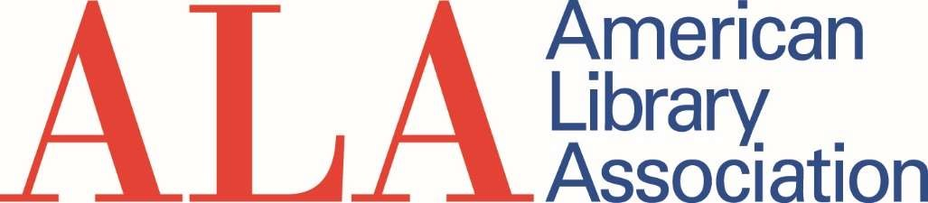

Overall Distribution: ALA and Units
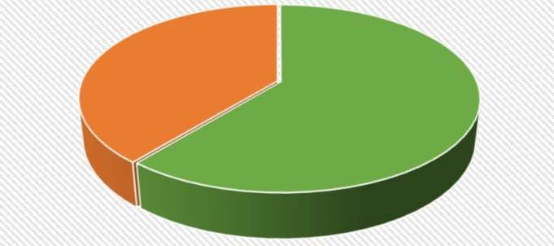
Unrestricted $0
Endowments
$16,055
Programs/Grants/
Sponsorships
$25,070

Distribution for ALA: Programs, Endowments and Unrestricted
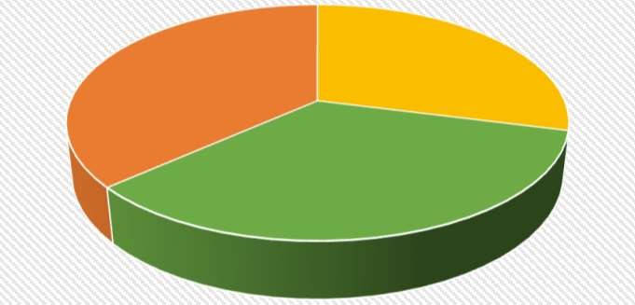
Endowments
$14,500
Unrestricted
$11,486
Programs/Grants/
Sponsorships
$13,605

Distribution for Units: Programs, Endowments and Unrestricted
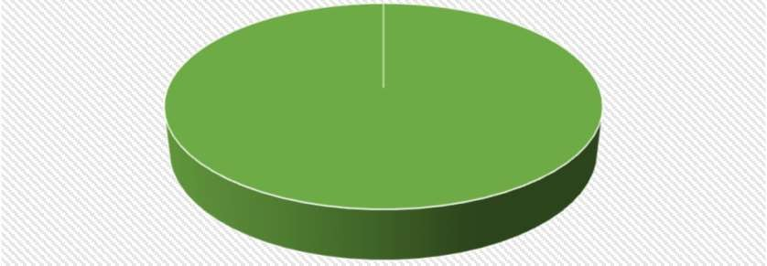
Endowment
s $0
Unrestricted
$0
Programs/Grants/
Sponsorships
$11,465

FY21 Q1 Giving from Corporations, Foundations, Organizations, Government, and Individuals, Breakdown
Q1 | ALA-  Unrestricted | ALA-  Program/Grants | ALA-  Endowments | Units- Unrestricted | Units- Program/Grants | Units- Endowments | Total
Corporation | - | $ 8,000 | - | - | $ 577 | - | $ 8,577
Foundation | $ 1,000 | - | - | - | - | - | $ 1,000
Government Agency | - | - | - | - | - | - | $ -
Non-Profit | - | $ 4,000 | $ 5,200 | - | $ 3,360 | - | $ 12,560
Individuals | $ 10,486 | $ 1,605 | $ 9,300 | $ 9,717 | $ 7,529 | $ 1,555 | $ 40,192
Total | $ 11,486 | $ 13,605 | $ 14,500 | $ 9,717 | $ 11,466 | $ 1,555 | $ 62,329

