EBD #12.7
2020-2021
TO: ALA Executive Board

RE: Development Office Fundraising Report to the Executive Board

ACTION REQUESTED/INFORMATION/REPORT:
Development Office Fundraising Report to the Executive Board

CONTACT PERSON:
Tracie D. Hall, Executive Director, ALA
Anne Manly, Assistant Director of Corporate and Foundation Relations, amanly@ala.org

DATE: October 2, 2020

DEVELOPMENT OFFICE FUNDRAISING REPORT TO THE EXECUTIVE BOARD

BACKGROUND: The purpose of the ALA Development Office report to ALA Executive Board Members is to provide an overview of the progress made by the American Library Association (ALA) and its units in their strategic fundraising efforts. The Development Office and ALA units expend significant effort in identifying, cultivating and soliciting major and planned gifts; participating in donor activities for purposes of relationship building, cultivation, and stewardship; drafting proposals and meeting with individuals, foundation, and corporate donors for cultivation and solicitation purposes.

Fundraising Accomplishments
The following are highlights of ALA’s Fundraising Activities, and Organizational Excellence since June 2020:

Association of College and Research Libraries
ACRL had 86 donors (including 12 ACRL sections) who donated a total of $15,875. Eighty-two percent of donations ($13,025) were designated for the ACRL Conference Scholarship Fund; 9.9% ($1,585) of donations were designated for the ACRL Advancement Fund; and 7.9% ($1,265) were designated for the Rare Books and Manuscripts Section Conference Fund.

Sixty-seven percent ($10,694) of the donations came from twelve ACRL sections which chose to donate their unused ACRL Basic Services Budgets to the Friends of ACRL. ACRL has raised more than $45,000 to support scholarships for the ACRL 2021 Conference.

Public Library Association
Third Microsoft grant expands PLA digital literacy and equity efforts Microsoft has continued its support of PLA’s digital skilling and access projects, fast-tracking two grants due to COVID-19. The newest funding ($100,000 plus 400 tablet computers in-kind) was provided in September 2020. Through this project, PLA will work both nationally and with libraries in four urban centers (tentatively Cleveland, El Paso, New York City and one other TBD) to highlight in-demand jobs and related digital skilling programs and certifications, available through LinkedIn, GitHub, Microsoft Learn and other sources. PLA and partner libraries will also provide 400 Microsoft Surfaces to families who are low income and/or negatively impacted by COVID-19. This funding follows Microsoft’s grant of $120,000 to PLA in May 2020. Those funds were used to provide WiFi access points to nearly 160 rural library locations to extend library signals into public spaces outside the library, which has been critical due to COVID-19 closures. PLA and Microsoft first collaborated in late 2019, using a $384,416 grant to provide 41 rural libraries with 158 hotspot devices, to initiate lending programs, and 156 computers, to conduct digital literacy training sessions.
PLA received IMLS grant for Latinx family engagement In July 2020, Institute of Museum and Library Services (IMLS) awarded the Public Library Association (PLA) and the National Center for Families Learning (NCFL) a $99,949 planning grant under the National Leadership Grants for Libraries category (LG-246412-OLS-20). The September 2020-August 2021 project will employ a co-design process, involving recipients of services in the creation of those services, to identify culturally responsive practices and resources that fully and authentically engage historically marginalized Latinx communities in library programs. This strategy aligns with components of the PLA family engagement framework urging libraries to “raise up” family voices, elevating family perspectives to develop and improve programs and services. The project will work with the Dallas Public Library, Arapahoe Libraries (Sheridan, Colo.), and Forest Grove City Library (Ore.) and Latinx families in their communities.
Public Programs Office
PPO received $3 million contribution from private donor for small/rural library grant program. PPO has received $3 million from a private donor in support of Libraries Transforming Communities: Focus on Small and Rural Libraries, a grant program to help small and rural libraries address community needs. Nearly $2 million will be awarded to members of ALA and the Association for Rural & Small Libraries (ARSL) as $3,000 grants. The grants — up to 650 to be awarded in 2020 and 2021 — will support the libraries in tackling issues ranging from media literacy to COVID-19 safety to unemployment. The initiative is part of ALA’s longtime commitment to preparing library workers for the expanding role of libraries. Library workers may apply online for grant funding until December 2, 2020, at ala.org/LTC. Selected libraries will develop their facilitation skills through online training; talk with community members (virtually or in-person) about local needs; and undertake a project that benefits their community. Grant funds may cover a range of expenses, from hotspot purchases to personal protective equipment to staff time to undertake community engagement work. A second funding round will open in January 2021. Libraries Transforming Communities: Focus on Small and Rural Libraries is offered in partnership with ARSL. The initiative has also been supported by the Institute of Museum and Library Services (IMLS).
PPO received $278,108 federal humanities relief for pandemic-era library programming resources, program support. The National Endowment for the Humanities (NEH) awarded PPO $278,108 in emergency relief funds in June to support humanities projects, including the creation of humanities content and resources for library workers in the face of the COVID-19 global pandemic. The funding, awarded through the NEH Coronavirus Aid, Relief, and Economic Security (CARES) Act, supports the development of professional development materials to help libraries present virtual and socially distanced programming for their communities.
Library workers may access free articles, webinars and interviews sharing best practices and resources for developing, promoting and hosting humanities-based programming that align with health and safety precautions of the COVID era. So far, published content has included “Black Bethlehem: Documenting the Black Experience in a Majority-White Town” and the webinar: “An Outrage: Hosting a Virtual Scholar-Led Screening and Discussion.” The CARES funding also supports the continuation of national PPO humanities programming initiatives for libraries that had been suspended due to the pandemic. These include traveling exhibitions under development for touring to libraries; in-development film, reading and discussion programs; and measurement and evaluation projects. Work will be carried out from June to December 2020.
Development Office Activities and Organizational Excellence
ALA Executive Director Tracie D. Hall continues to serve as the Director of the Development
Office. In that capacity, Tracie and Development have met with several past, current and
potential funders. These meetings are in the relationship-building stage and we are optimistic that these efforts will show good results.

The Development Office’s budget projects revenue of $2,500,000 for the coming year. This represents a significant increase over previous years and reflects several factors, including Tracie Hall’s leadership and significantly increased focus by the Development Office on the identification, expansion and stewardship of potential donors.

Genevieve Hix, ALA Assistant Director of Development, Major Gifts, ended her employment with ALA on October 9, 2020 to accommodate her move to Boise, Idaho.

The Development Office has been working with AASL since early winter to reach an agreement
with Pokemon for program support. The parties have signed a Non-Disclosure Agreement and
remaining details are being worked out.

Tracie Hall and the Development Office conducted several conversations with FreeWill.
Freewill is a social venture that provides non-profits with fundraising tools in the areas of (1)
Planned Giving, (2) Qualified Charitable Distributions and (3) Stocks, Mutual Funds and Bonds.
They claim to “build technology to make the most impactful gifts easier for supporters to
give and simpler for organizations to receive.” Conversations are on-going and Executive
Director Hall has directed the Development Office to get input from ALA’s Endowment Trustees
and others.

Development met with PPA to increase our competency in Salesforce and we are evaluating how to use Salesforce in future initiatives.

Development and OverDrive reached an agreement to increase OverDrive’s support as Lead sponsor of the Library Champions program. OverDrive’s support is increased from $50,000 last year to $88,000 this year. In addition, OverDrvie’s support will extend to the Membership Office and the Spectrum Scholarship program.

The Development Office met with Finance to discuss gift-processing challenges arising from the termination of the EXL contract.

The Development Office is working with several Units on new fundraising initiatives or to increase previous initiatives. We hope to make announcements about concrete results soon.

ALA is pleased to have received the following major gifts and bequests:
Pledges
From Marney Welmers, a $10,000 gift in support of ALA’s general fund.
A new pledge from Betty Turock annually to support Spectrum Scholarships.
Gifts
YALSA has received nearly $30,000 in memory of Joann Sweetland Lum, beloved wife of Gregory, to be used for scholarships for students pursuing careers in young adult services.
Bequests:
ALA is delighted to receive a bequest in the amount of $100,000 from the estate of Jay and Ruth Toor for scholarships to attend AASL conferences.
The Julia Brody endowment generously donated $100,000 for scholarships for people pursuing careers as public librarians.
ALA is honored to be the recipient of the Ann Symons and Robert Newlen Legacy Fund to support advocacy and outreach activities of the Rainbow Round Table and the New Members Round Table. The Fund is generously supported by a gift from Ann Symon’s estate and Robert Newlen’s estate
Philanthropy Advisory Group
PAG is honored to have Janice Wellborn recently join PAG as the Endowment Trustee representative. The Development Office worked closely with PAG leadership to host PAG’s second day-long retreat in August. In addition, PAG addressed Units Managers and presented ideas for building a cluture of philanthropy within ALA.
Development Office work with ALA Units
Pursuant to Tracie's directive that all Units explore ways they can become revenue generating units, the Development Office began meeting with all ALA Units to work with them on stewardship, prospecting, developing a culture of philanthropy within the association and developing revenue streams where possible.
The Development Office continues to regularly alert other Units to grant opportunities that may be of interest to them.

ALA Fundraising Priorities

Annual Fund
Development is preparing for the Annual Fund and ALA’s Giving Tuesday campaign. We aim to have a solicitation letter out to donors in November and are working to secure donor “challenge funds” for Giving Tuesday to increase donor participation. This year, we are sending the solicitation letter to a much more targeted group than in years past. The goal is to create more frequent, targeted mailings, rather than relying on one large end-of-year mailing. We are on track to send the letter earlier than FY20, which fulfills a goal we set for ourselves last year. We are also working with a new mailing house to address some of the timing challenges we faced with our mailing house last year. The letter is focused on digital equity.

Libraries Transform Campaign - Library Champions
During 2019-2020, the Development Office evaluated and revitalized the Library Champions program. Input from the Champions, as well as from a number of ALA Units, guided Development efforts. Feedback from the Champions indicates that they are pleased with new visibility and sponsorship opportunities, ALA communication, and use of ALA social media.
After some initial concern that the economic fall-out from the pandemic would result in lower Library Champion memberships, we have seen a recent uptick in Library Champion renewals. A month ago there were seven outstanding renewals but we now currently awaiting only three.

See below for a breakdown of gifts by Corporations, Foundations, Organizations, Government, and Individuals.

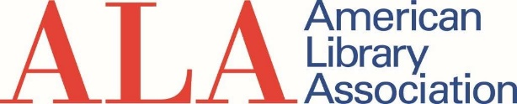
Donations and Grants, FY 2020 Q1 - Q4 - September 1, 2019 - August 31, 2020

Individuals
Type | Number of  Donors | Number of Gifts | Amount | Median | Average
ALA Unrestricted | 748 | 916 | $ 57,448 | $ 25 | $ 63
ALA Programs/Grant/Sponsorships | 186 | 225 | $ 12,031 | $ 25 | $ 53
ALA Endowment | 588 | 830 | $ 227,213 | $ 35 | $ 274
Unit Unrestricted | 512 | 693 | $ 90,260 | $ 25 | $ 130
Unit Programs/Grants/Sponsorships | 410 | 803 | $ 222,168 | $ 25 | $ 277
Unit Endowment | 101 | 120 | $ 10,728 | $ 25 | $ 89
 | 2130* | 3587 | $ 619,848 | $25 | $ 173

*The total reflects the number of unique donors. Total number of unique donors is less than the sum of donors listed in each row because some donors contributed to more than one gift category.

FY 2019
Individuals
Type | Number of  Donors | Number of Gifts | Amount | Median | Average
ALA Unrestricted | 671 | 755 | $ 62,169 | $ 25 | $ 82
ALA Programs/etc. | 252 | 295 | $ 14,526 | $ 30 | $ 48
ALA Endowment | 650 | 875 | $ 90,846 | $ 50 | $ 104
Unit Unrestricted | 542 | 695 | $ 80,581 | $ 25 | $ 115
Unit Programs/etc. | 440 | 561 | $ 299,806 | $ 50 | $ 528
Unit Endowment | 140 | 159 | $ 7,716 | $ 25 | $ 48
 | 2186 | 3340 | $555,644 | $25 | $ 165

*The total reflects the number of unique donors. Total number of unique donors is less than
the sum of donors listed in each row because some donors contributed to more than one gift category.

FY2018
Individuals
Type | Number of  Donors | Number of Gifts | Amount | Median | Average
ALA Unrestricted | 665 | 773 | $ 40,927 | $ 25 | $ 53
ALA Programs/etc. | 500 | 652 | $ 50,433 | $ 35 | $ 77
ALA Endowment | 640 | 796 | $ 75,833 | $ 35 | $ 95
Unit Unrestricted | 573 | 803 | $ 83,000 | $ 25 | $ 103
Unit Programs/etc. | 498 | 657 | $ 303,148 | $ 50 | $ 461
Unit Endowment | 165 | 211 | $ 30,582 | $ 25 | $ 145
 | 2446* | 3892 | $ 583,923 | $ 35 | $ 150

*The total reflects the number of unique donors. Total number of unique donors is less than
the sum of donors listed in each row because some donors contributed to more than one gift category.

Donations and Grants, FY 2020 Q1 - Q4 - September 1, 2019 - August 31, 2020

Giving from Corporations, Foundations, Organizations and Government
Type | Number of  Donors | Number of Gifts | Amount | Median | Average
ALA Unrestricted | 25 | 48 | $ 70,654 | $ 205 | $ 1,472
ALA Programs/Grant/Sponsorships | 23 | 33 | $ 182,456 | $ 4,000 | $ 5,529
ALA Endowment | 12 | 13 | $ 392,712 | $ 2,738 | $ 30,209
Unit Unrestricted | 17 | 27 | $ 21,738 | $ 200 | $ 805
Unit Programs/Grants/Sponsorships | 108 | 135 | $ 4,491,162 | $ 2,061 | $ 33,268
Unit Endowment | 2 | 2 | $ 1,560 | $ 780 | $ 780
 | 167* | 258 | $ 5,160,282 | $ 1,350 | $ 20,001

*The total reflects the number of unique donors. Total number of unique donors is less than the sum of donors listed in each row because some donors contributed to more than one gift category.

FY 2019

Giving from Corporations, Foundations, Organizations and Govt.
Type | Number of  Donors | Number of Gifts | Amount | Median | Average
ALA Unrestricted | 20 | 63 | $ 164,728 | $ 200 | $ 2,615
ALA Programs/etc. | 52 | 72 | $ 1,738,069 | $ 4,000 | $ 23,809
ALA Endowment | 18 | 34 | $ 157,576 | $ 500 | $ 4,635
Unit Unrestricted | 41 | 61 | $ 90,983 | $ 400 | $ 1,467
Unit Programs/etc. | 218 | 313 | $ 4,537,474 | $ 1,500 | $ 14,451
Unit Endowment | 8 | 9 | $ 36,767 | $ 1,000 | $ 4,085
 | 311 | 552 | $ 6,725,597 | $ 1,000 | $ 12,118

*The total reflects the number of unique donors. Total number of unique donors is less than
the sum of donors listed in each row because some donors contributed to more than one gift category.

FY2018

Giving from Corporations, Foundations, Organizations and Govt.
Type | Number of  Donors | Number of Gifts | Amount | Median | Average
ALA Unrestricted | 23 | 54 | $ 185,715 | $ 215 | $ 3,439
ALA Programs/etc. | 81 | 112 | $ 615,830 | $ 1,750 | $ 5,498
ALA Endowment | 15 | 26 | $ 75,081 | $ 200 | $ 2,888
Unit Unrestricted | 27 | 45 | $ 89,652 | $ 400 | $ 1,992
Unit Programs/etc. | 228 | 330 | $ 16,696,445 | $ 1,500 | $ 50,595
Unit Endowment | 5 | 6 | $ 34,804 | $ 500 | $ 5,801
 | 333* | 573 | $ 17,697,526 | $ 1,000 | $ 30,886

*The total reflects the number of unique donors. Total number of unique donors is less than
the sum of donors listed in each row because some donors contributed to more than one gift category.

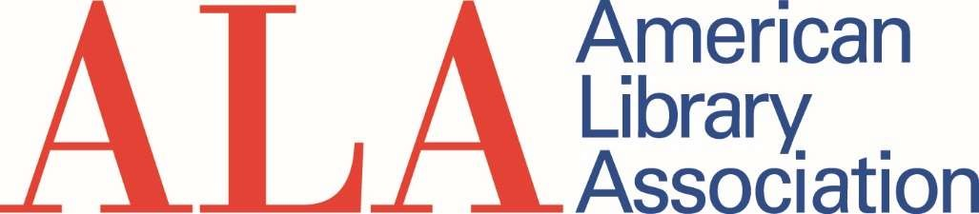

Overall Distribution: ALA and Units
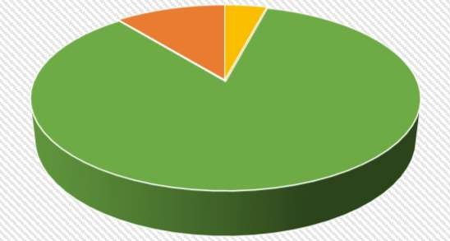
Endowments
$630,653
Unrestricted
$240,100
Programs/Grants/
Sponsorships
$4,907,817

Distribution for ALA: Programs, Endowments and Unrestricted
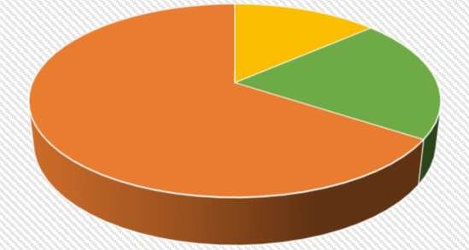
Unrestricted
$128,102
Endowments
$619,925
Programs/Grants/
Sponsorships
$194,487

Distribution for Units: Programs, Endowments and Unrestricted
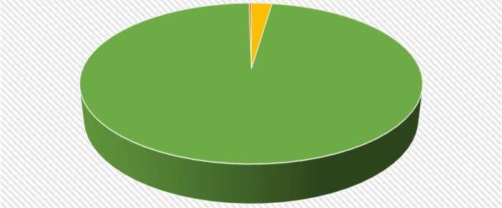
Endowments
$12,288
Unrestricted
$111,998
Programs/Grants/
Sponsorships
$4,713,330

FY20 Q1-Q4 Giving from Corporations, Foundations, Organizations, Government, and Individuals, Breakdown
Q1+Q2+Q3 | ALA-  Unrestricted | ALA-  Program/Grants | ALA-Endowments | Units-  Unrestricted | Units-  Program/Grants | Units-  Endowments | Total
Corporation | $ 30,315 | $ 62,600 | $ 304,081 | $ 17,323 | $ 680,747 | $ 1,560 | $ 1,096,625
Foundation | $ 33,805 | $ 63,600 | $ 67,886 | $ 3,430 | $ 3,456,000 | - | $ 3,624,721
Government Agency | - | $ 47,101 | - | $ 500 | $ 88,393 | - | $ 135,994
Non-Profit | $ 6,533 | $ 9,155 | $ 20,745 | $ 485 | $ 266,023 | - | $ 302,941
Individuals | $ 57,448 | $ 12,031 | $ 227,213 | $ 90,260 | $ 222,168 | $ 10,728 | $ 619,848
Total | $ 128,102 | $ 194,487 | $ 619,925 | $ 111,998 | $ 4,713,330 | $ 12,288 | $ 5,780,130

