**EBD # 12.11.1**

**2020-2021**

**TO:** ALA Executive Board

**RE:** ALA Membership Report

**ACTION REQUESTED/INFORMATION/REPORT:**

Information report

**ACTION REQUESTED BY:**

Melissa Walling, MBA, CAE, Director, Member Relations & Services

**CONTACT PERSON:**

Melissa Walling, mwalling@ala.org, ext. 2159

**DRAFT OF MOTION:**

N/A

**DATE:** Friday, October 2, 2020

**BACKGROUND:**

Report on membership activities and recommended membership model.

**ATTACHMENTS:**

For those not familiar with the history of the membership model work, please visit:

EBD 12.20 (2019-2020): [Membership Presentation](http://www.ala.org/aboutala/sites/ala.org.aboutala/files/content/governance/ExecutiveBoard/20192020Docs/ebd%2012.20%20Fall%202019%20Board%20Membership%20Presentation.pdf)

EBD 12.12 (2018-2019): [Communications/Membership Reports (PowerPoint)](http://www.ala.org/aboutala/sites/ala.org.aboutala/files/content/ebd12_12_ALA_survey_results_AvenueM_presentation.pdf)

**FY21 Key Membership Activities and Focus Areas**

While ALA’s monthly membership statistics are delayed, we have pulled together a rough estimate of our membership numbers. This is only an estimate. Overall ALA’s membership is a 6% decline YOY and a 9% decline when compared to two years ago. This is due to three primary factors - the impact of COVID-19, the cancellation of Annual Conference, and because membership renewal tactics were paused in March and resumed in late July.

**Membership Renewals:** As previously reported, membership renewals resumed in July via email and we are issuing print renewal next week to approximately 15,000 members. Monthly membership renewals remain on track and we are playing catch up to some of the members impacted by this interruption. Since July, we have collected $850,000 in membership dues revenue which will impact both of our FY20 and FY21 budgets. Continuing to highlight the semi-annual installment payments and the non-salaried membership price are important messages during this time when members need flexibility and their employment outlook may be uncertain. Our lapsed member survey indicates that cost, unemployment, furloughs and retirement are some of the reasons why people are discontinuing membership.

**ALA Connect Live:** ALA Connect Live has proven to be an engaging virtual event for our members. President Jefferson has curated speakers that highlight the diverse work of the association including division, offices and round tables initiatives. On average, 90% of attendee rank the program as very good or excellent and nearly 2/3 of attendees would recommend the program to a colleague. One recent attendee remarked, “Even if I do not attend a lot of these, I really appreciate that they are there.”

**Membership Onboarding:** The experience a new member has in their first 12 months of membership greatly impact their long-term relationship. Currently, there is not a membership onboarding program for ALA membership, but one will be launched this fiscal year. A cross-organizational team is working to develop emails, videos, virtual meet ups, and web pages to ensure that our new members learn about everything ALA membership can offer. Demonstrating the value proposition of membership is always important, and even more so during this economic downturn. This effort is being supported through the sponsorship of OverDrive.

**Membership Benefits:** We are continuing to identify opportunities to increase the benefits that are offered to our members. Here are a few recent benefits that have been activated:

* The staff of organizational members are able to receive access to the ALA Annual Conference recordings beginning November 1st when enrolling through an online form.
* Organizational members who purchase multiple registrations and/or a group license for one or more ALA Publishing eLearning Solutions events exceeding $1,000, can receive discounts of up to 25% off the regular rate.
* The digital access to For *Banned Books: Defending Our Freedom to Read* was provided as a member only resource during Banned Books Week

**Membership Recruitment:** We continue to collaborate across the organization to engage non-members. This includes non-members customers, attendees and grant recipients and we are working towards operationalizing these outreach efforts. ALA’s Pivot Plan reflects continued membership growth and we are striving to increase our market share of library workers and engage library lovers.

**Membership Model Updated – Feedback Requested**

**Overarching Goals of Membership Model:**

As noted in ALA policy (Section A.1.6) Member Engagement Goal Statement: ALA provides an environment in which all members, regardless of location or position, have the opportunity to participate in, contribute to, and benefit from engagement in their association.

With a market share of approximately 15%, there is great potential for growth; however, recent research has indicated that the complexities and cost of the membership model is a barrier to membership. As presented to the board in Fall, 2019 (EBD 12.20), the Membership Committee is recommending a modification to the membership model to achieve the following goals: Simplicity, Flexibility, and Personalization. We want to ensure that this model positions ALA as the professional membership home for *all* library workers especially those not currently represented within our membership.

In 2018, ALA contracted with a market research firm, Avenue M which presented five recommended models to ALA. After review and deliberation, the Membership Committee is recommending a two-phase approach to ALA’s membership model work:

**Phase One:** Consolidate the eleven (11) membership categories into four (4) membership categories. The goal would take effect in FY23 (Executive Board, Council and Member Vote in Early, 2022) and would not change division or round table structures. See Table 1: Phase One Recommendations for more details.

**Phase Two:** Building upon Phase One, launch an “enhanced” membership package which will include a bundle of additional benefits. Examples of the bundled benefits may include a division, a round table membership and/or professional development offerings.

With the two-phase approach, the Membership Committee is focusing on the first goal of simplification with this collapsed model. We are also aiming to launch the monthly installment payment plan to ensure flexibility and affordability. Phase two will tackle the goal of personalization.

**Phase One – for Board Feedback:**

Consolidate the eleven (11) membership categories as outlined below. All member benefits and privileges will remain the same as they do today including discounts, voting rights and ability to volunteer.

Pros – Consistent dues for members will minimize confusion and promote ease of access and equity as members will be able to engage with ALA under four (4) simple categories. Additionally, this will decrease the amount of time spent on inquiries, technology mapping, and membership recruitment efforts.

Cons – While this achieves the goal of simplification, this does not achieve the goal of flexibility. The pricing may not be different enough to combat the opinion that our dues are too expensive.

**Phase Two:**

Due to a lack of pricing standardization, the Membership Committee is unable to conduct a financial analysis on bundling including division membership, round table membership or online learning offering. Phase Two will begin when some of the standardization initiatives across the organization conclude and the financial analysis and technology requirements can be conducted.

**Table 1: Phase One Recommendation**

|  |  |  |  |  |  |
| --- | --- | --- | --- | --- | --- |
| **Current Member Type** | **Feb. 2020 Counts** | **Current Dues** | **New Member Type** | **Proposed Dues** | **Notes** |
| 1st year | 4,950 | $74 | **Professional – Option 1**  (Includes library workers as well as others employed in library and information services or related activities in positions) | **TBD** | Positions that (a) require a Masters degree; or (b) require a state-level certification; or (c) are managerial.  *Higher rate of dues than option 2* |
| 2nd year | 2,911 | $112 |
| 3rd year+ | 21,253 | $148 |
| Earning <$30,000 | 2,929 | $53 | **Professional – Option 2**  (Includes library workers as well as others employed in library and information services or related activities in positions) | **TBD** | Positions other than those listed in Level 1 and including those who are (a) earning < $30K annually; or (b) working outside the U.S.; or (c) retired. |
| Support Staff | 1,529 | $53 |
| Retired | 2,144 | $53 |
| International | 750 | $89 |
| Student | 8,351 | $39 | **Student**  (Includes individuals enrolled in a degree or certificate program in library and information studies.) | **TBD** | *Eligible for five years. Graduating students will remain in this category to help transition to the price of the professional membership.* |
| Associate | 561 | $67 | **Advocates**  (Includes those not employed in library and information services or related activities who, through their personal commitment and support, promote library and information services.) | **TBD** |  |
| Trustee | 987 | $67 |
| Friend | 160 | $67 |

**Next Steps:**

* Request Board feedback – October, 2020
* Continue to review financial scenarios and costs of modifying technology – Winter, 2020
* Conduct a pilot recruitment test in Spring/Summer, 2021
* Formalize recommendation from Membership Committee– Fall, 2021

**ALA Connect Dashboard**

ALA Connect is a key member benefit and as more communities transfer onto Connect, we are monitoring key metrics to ensure that this remains a relevant and useful tool for our members. Here is a snapshot of some of the data we are monitoring which all reflects an upward trend in usage and engagement.

**Key Performance Indicator: Logins to the Web site**

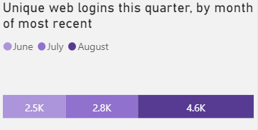

**Key Performance Indicator: Engagement**

Posting in the “all member” communities (this chart excludes divisions and round table communities which are being monitored at the community level)

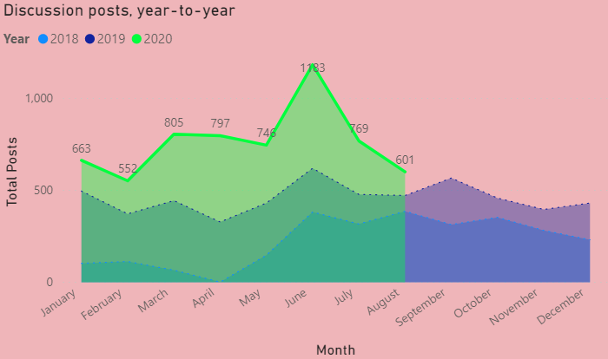

We are also looking at trending topics on the community. Here are the 10 most active topics in the last quarter

